# “RESTAURANT MENU MANAGEMENT SYSTEM”

### A Project report submitted

**In the partial fulfillment the award of degree of**

**BACHELOR OF TECHNOLOGY**

**IN**

**COMPUTER SCIENCE AND ENGINEERING (2022-2023)**

**BY**

**SK REENA SULTANA Reg.No.211801370064**

**Under the esteemed Guidance of**

**Mrs. G. Rama Devi, M.Tech,(Ph.d),Asst. Professor**

**CENTURION UNIVERSITY SCHOOL OF ENGINEERING AND TECHNOLOGY**

**Rollavaka village, Tekkali mandal 535003**

**(2022-2023)**

##### CENTURION UNIVERSITY OF TECHNOLOGY AND MANAGEMENT

**ANDHRA PRADESH**

**(2019-2023)**

##### DEPARTMENT OF COMPUTER SCIENCE AND ENGINEERING

BONAFIDE CERTIFICATE

##### This is to certify that the project work entitled “RESTAURANT MENU MANAGEMENT SYSTEM” is a fulfillment of project work done by SK REENA SULTANA (Reg.No.211801370064) for the award the degree of BACHELOR OF TECHNOLOGY in COMPUTER SCIENCE AND ENGINEERING, CENTURION UNIVERSITY OF TECHNOLOGY AND MANAGEMENT, during the academic year 2022-2023.

##### INTERNALGUIDE HEAD OF THE DEPARTMENT

##### Mrs .G. Rama Devi Mr.R. Lakshmana Rao

**Asst. Professor Asst. Professor**

**Dept. of CSE Dept. of CSE**

**EXTERNAL EXAMINER**

**ACKNOWLEDGEMENT**

It is with at most pleasure and excitement we submit our project partial fulfillment of the requirement for the award of Bachelor of Technology.

The project is a result to the cumulate efforts, support, guidance, encouragement and inspiration from many of those for whom we have to give our truthful honor and express gratitude through bringing out this project at the outset as per our knowledge.

I convey my special thanks to our project **Guide Mrs. G. Rama Devi(Asst. Professor)** who has guided, encouraged and tremendously supported me to enhance my knowledge with present working of this project to bring out enriching the quality of project.

I express my appreciativeness to **Mr. R.LAKSHMAN RAO(Asst. Professor) and Head of the Department,** who facilitated us to providing the friendly environment which helped to enhance my skills in present project.

I would also like to extend my gratitude to **Dr. K. V. G. KRISHNA MURTHY, Dean-School of Engineering And Technology, Centurion University of Technology and Management** who has helped us to attain all the requirements of the project.

I convey my sincere thanks to **Dr. RAMANA RAO, Ph. D Registrar of Centurion University of Technology and Management** who provided us with an opportunity to take on project work in well-equipped laboratories of Computer Science Department in our college.

At the outset, we thank to **Sri. G.S.N.RAJU**, beloved **Vice Chancellor of Centurion University of Technology and Management** who is the back bone by providing for completion of this project, Thank you sir.

**DECLA****RATION**

I hereby declare that the project entitled **“**Restaurant Menu Management System**”** submitted to the fulfillment of award the degree of **B.TECH (CSE)** in **CENTURION UNIVERSITY OF TECHNOLOGY AND MANAGEMENT**, **ANDHRA PRADESH.**

**SK REENA SULTANA Reg.No.211801370064**

1. **Introduction**
   1. **Purpose**
   2. **Document Conventions**
   3. **Project scope**
   4. **Overview**
   5. **References**
2. **Overall Description**
   1. **Product Perspective**
   2. **Product functions**
   3. **User classes and Characteristics**
3. **System Features**
   1. **Functions Requirements**
4. **External Interface Requirements**
   1. **User Interfaces**
   2. **Hardware Interfaces**
   3. **Software Interfaces**
5. **Nonfunctional Requirements** 
   1. **Performance Requirements**
   2. **Safety Requirements**
   3. **Security Requirements**
   4. **Software Quality Attributes**

# Introduction

The following section provides an overview of the derived Software Requirements Specification (SRS) for the Restaurant Menu Management System (RMS) topic. It begins by introducing the purpose of the document and outlining the target audience. Then, the scope of the project specified by the document is given, focusing on the resulting software's features and associated benefits. The nomenclature used in the SRS is also presented. Finally, a complete overview of the document is provided to assist the reader in understanding and navigating it.

* 1. **Purpose**

The purpose of this SRS is to outline both the functional and non-functional requirements of the subject RMS. In addition to said requirements, the document also provides a detailed profile of the external interfaces, performance considerations and design constraints imposed on the subsequent implementation. It is the intention that the presented set of requirements possesses the following qualities; correctness, unambiguousness, completeness, consistency, verifiability, modifiability and traceability. Consequently, the document should act as a foundation for efficient and well-managed project completion and further serve as an accurate reference in the future. The primary audience of this SRS document will be the development team employed to implement the specified RMS. It will not only provide an extensive capacity for project planning and progress assessment but it will further assist with developer/stakeholder interactions. The secondary document audience comprises the stakeholders of the project, that is, restaurateurs and associated staff.

* 1. **Document Conventions**

This document presents a detailed explanation of the objectives, features, user interface and application of restaurant management system in real life. It will also describe how the system will perform and under which it must operate. In this document it will be also shown user interface. Both the stakeholders and the developers of the system can benefit from this document.

* 1. **Project scope**

In current formal dining environments, some form of physical static menu is utilized to convey the available food and beverage choices to customers. Said menus are generally paper based and hence impose restrictions on the textual real estate available and the ability a restaurateur has to update them. This document specifies the requirements for a restaurant paper menu replacement strategy to alleviate the problems associated with the current archaic method. Three related concepts are encompassed by the general scope of the Restaurant Menu. It should be noted that while the suggested strategy incorporates the use of various hardware components, the primary focus of the presented SRS relates to the constituent software elements.

## **1.4 Overview**

We are going to focus on describing the system in terms of product perspective, product functions, user characteristics, assumptions and dependencies on the following section of this document. Next, we will address specific requirements of the system, which will enclose external interface requirements, requirements of the system, performance requirements, and other requirements.

* 1. **References**
* <https://www.irjmets.com/uploadedfiles/paper//issue_5_may_2022/24909/final/fin_irjmets1654409408.pdf>
* <https://free-projects/php-project/online-restaurant-management-system-project-in-php/>
* <https://projectsgeek.com/2022/03/online-restaurant-management-system.html>

# Overall Description

The Restaurant Menu Management System is a software package to facilitate a traditional restaurant. The customer is able to view the menu, call the waiter, and organize the final bill through the surface computer interface built into their table. Waiters are able to initialize a table for customers, control table functions remotely to assist customers, send orders to food preparation staff and finalize the bill – all through their wireless tablet PC. The food staff, with their touch-display interfaces to the system, are able to view orders sent to the kitchen by waiters. During preparation, they are able to let the waiter know the status of each item, and can send notifications when items are completed, again through the touch display. The system contains full accountability and logging systems, and supports supervisor actions to account for exceptional circumstances, such as a meal being refunded or walked out on. Customers are presented with an attractive and easy-to-use surface computer tablet PCs, so in the event of a customer being unable to operate the surface computer, the waiter can handle orders traditionally while using retaining the accountability and logging functions of the system, and retaining the same channel of communication with food staff.

## **Product Perspective**

The Restaurant Management System helps the restaurant manager to manage the restaurant more effectively and efficiently by computerizing meal ordering, billing and inventory control. The system processes transaction and stores the resulting data. Reports will be generated from these data which help the manager to make appropriate business decisions for the restaurant. For example, knowing the number of customers for a particular time interval, the manager can decide whether more waiters and chets are required. Moreover, easily calculate daily expenditure and profit. The whole management system is designed for a general Computerized Digital Restaurant. So that any restaurant owner can get it and can start automated process to his restaurant.

## **Product Functions**

Whole functions will performed through this order.

* Customer Information
* Available food
* Required foods
* Food order
* Payment
* Customer Review

Select the category user wanted to eat

Select the category user wanted to eat

Select the food which user wanted to eat

Check the cart and place order

Payment

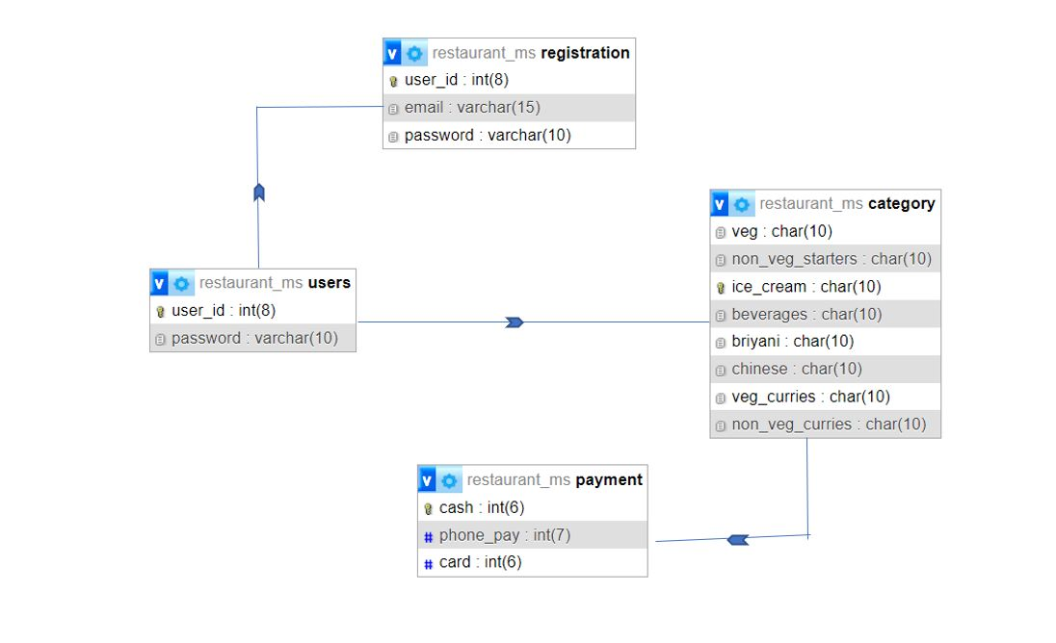

* 1. **User classes and Characteristics**

The restaurant management system has five active actors and one cooperating system. The customer can access the system through WIFI connection. The chef can see the order and after preparing the food he will tell the system that the food is ready. The waiter can get the confirmation of food from the chef through the system and deliver it to the right table. The cashier can access the system and receive the payment from customers. The admin can edit the price, count total earning and expenditure.

1. **System Features**

**3.1 Functions Requirements**

**Menu Management:**

The system should allow the user to manage the restaurant's menu, including adding new items, updating prices, and managing ingredient availability. The menu can be displayed in a user-friendly format using CSS and JavaScript.

**Payment Management:**

The system should allow the user to manage payments, including processing payments, generating invoices, and managing refunds. This can be developed using JavaScript to integrate with payment gateways and CSS to display the payment information.

1. **External Interface Requirements**

There are many types of interfaces as such supported by this software system namely user interfaces, software interfaces and hardware interfaces.

**4.1 User Interfaces**

The user interface will be implemented using any visual studio . This interface will be user friendly. So that every kind of customer can place the food order easily.

**4.2 Hardware Interfaces**

• 2GB ram

• 1.2 GHz processor

• Intel i5

• Windows 7/8/8.1/10

**4.3 Software Interfaces**

• Html

• CSS

• Java script

• PHP

1. **Nonfunctional Requirements** 
   1. **Performance Requirements**

* The product will be based on local server.
* The product will take initial load time.
* The performance will depend upon hardware components.
* Payment system will be fully secure through POS system.
* Different database for employee.
  1. **Safety Requirements**
* The source code developed for this system shall be maintained in configuration management tool.
* The whole system is secured Only admin can access all the data.
* The software is completely environmentally friendly and does not cause any safety violations.
* The menu will have a flexible font that can be zoomed so as to not over constrain the eyes.
  1. **Security Requirements**
* This system will use HTTPS. because of this protocol this is more secure.
* This system will use secured POS system.
* There is a need for a proper and encrypted login authentication for head chef and admin as employee sensitive information as well as inventory should be protected from hacking.
* Information transmission should be securely transmitted to Firebase without any changes in information to avoid disturbances in orders and billing.
  1. **Software Quality Attributes**

**Adaptability:**

There can be a change in the menu and information stored in the database about employees and inventory.

**Availability:**

The system is up and running for most of the time of the time and server is not down for more than a few minutes to avoid inconvenience of the customers.

**Correctness:**

The bill generated by the application must be accurate and the orders placed should exactly be the same which the user has selected.

**Flexibility:**

If need arises in the future, software can be modified to change the requirements.

**Interoperability:**

The data is transferred from the customer's end to the kitchen and then head chef assigns orders to each chef. This way data is transferred from one part of the system to another.

**Maintainability:**

Software can be easily repaired if a fault occurs.

**Portability:**

Software can be easily installed on devices and would run smoothly according to the requirement.

**Reliability:**

No matter how many orders are placed, system must give the correct results.

**Reusability:**

Current version can be used in the future versions with more functionality added.

**Robustness:**

Software must have checks to ensure that the items that are not available in the menu cannot be selected and the emails, phone numbers added are all valid.

**Testability:**

All the requirements are fulfilled, response time is low, and the functions are working perfectly.

**Usability:**

Interface of the software must be easy to use. It would not be complex since managers, chef have a view, so interface should be simple.